**COMPUTER NETWORKS - CSA07**

**Parthibhan .R**

**192224275**

**EXPRIMENT 4:-**

Data Link Layer Traffic Simulation using Packet Tracer Analysis of CSMA/CD& CSMA/CA

**GITHUB LINK**[**:-** **https://github.com/parthibhan007/CSA0748-computer-network/tree/main/expriment%204**](:-%20https:/github.com/parthibhan007/CSA0748-computer-network/tree/main/expriment%204)

**Simulation:-**

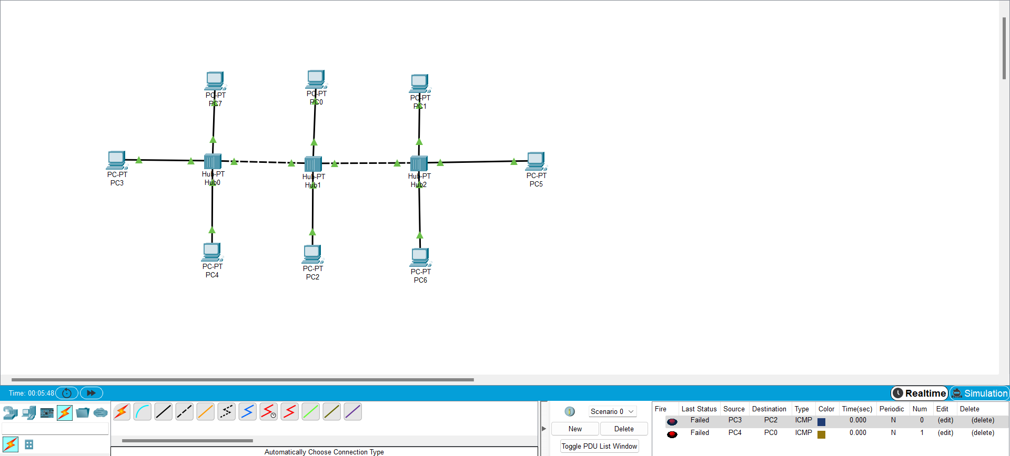

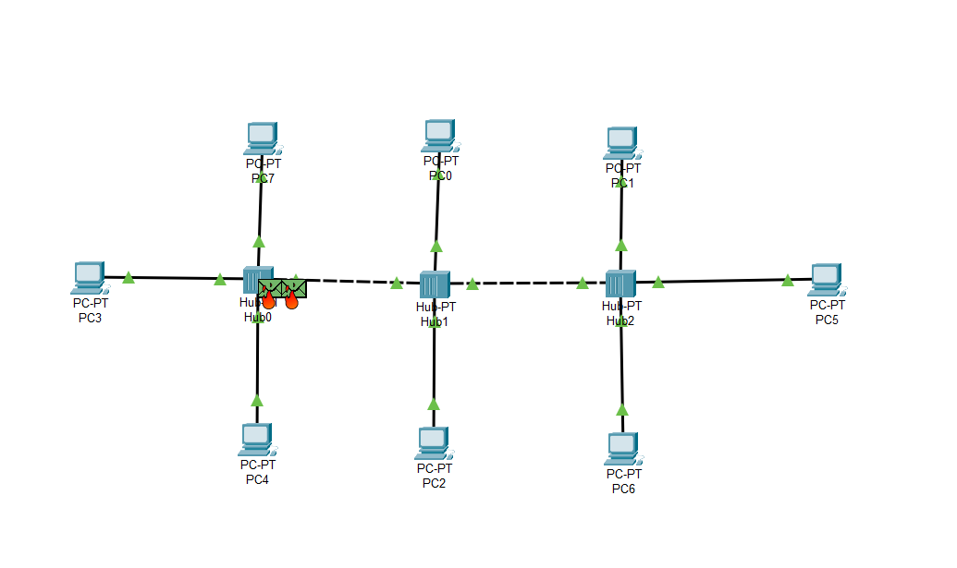

**Real Time:-**

